Overview

Yardley Wood Health Centre does not discriminate any patient on the grounds of race, gender, social class, age, religion, sexual orientation, appearance, disability or medical condition. Any refusal to accept an application to register will not be made without reasonable grounds.

Out of Area Registrations

Patients living outside of the Practice catchment area will be given the option to remain on the practice register. An SMS(Annex 1) will be sent to the patient advising them that they have moved outside of our catchment area however can remain on the list should they agree to the following:
- No home visits
- Any issues around community care referral (eg midwifery services/district nurse services) will be at the patients risk

Catchment Area

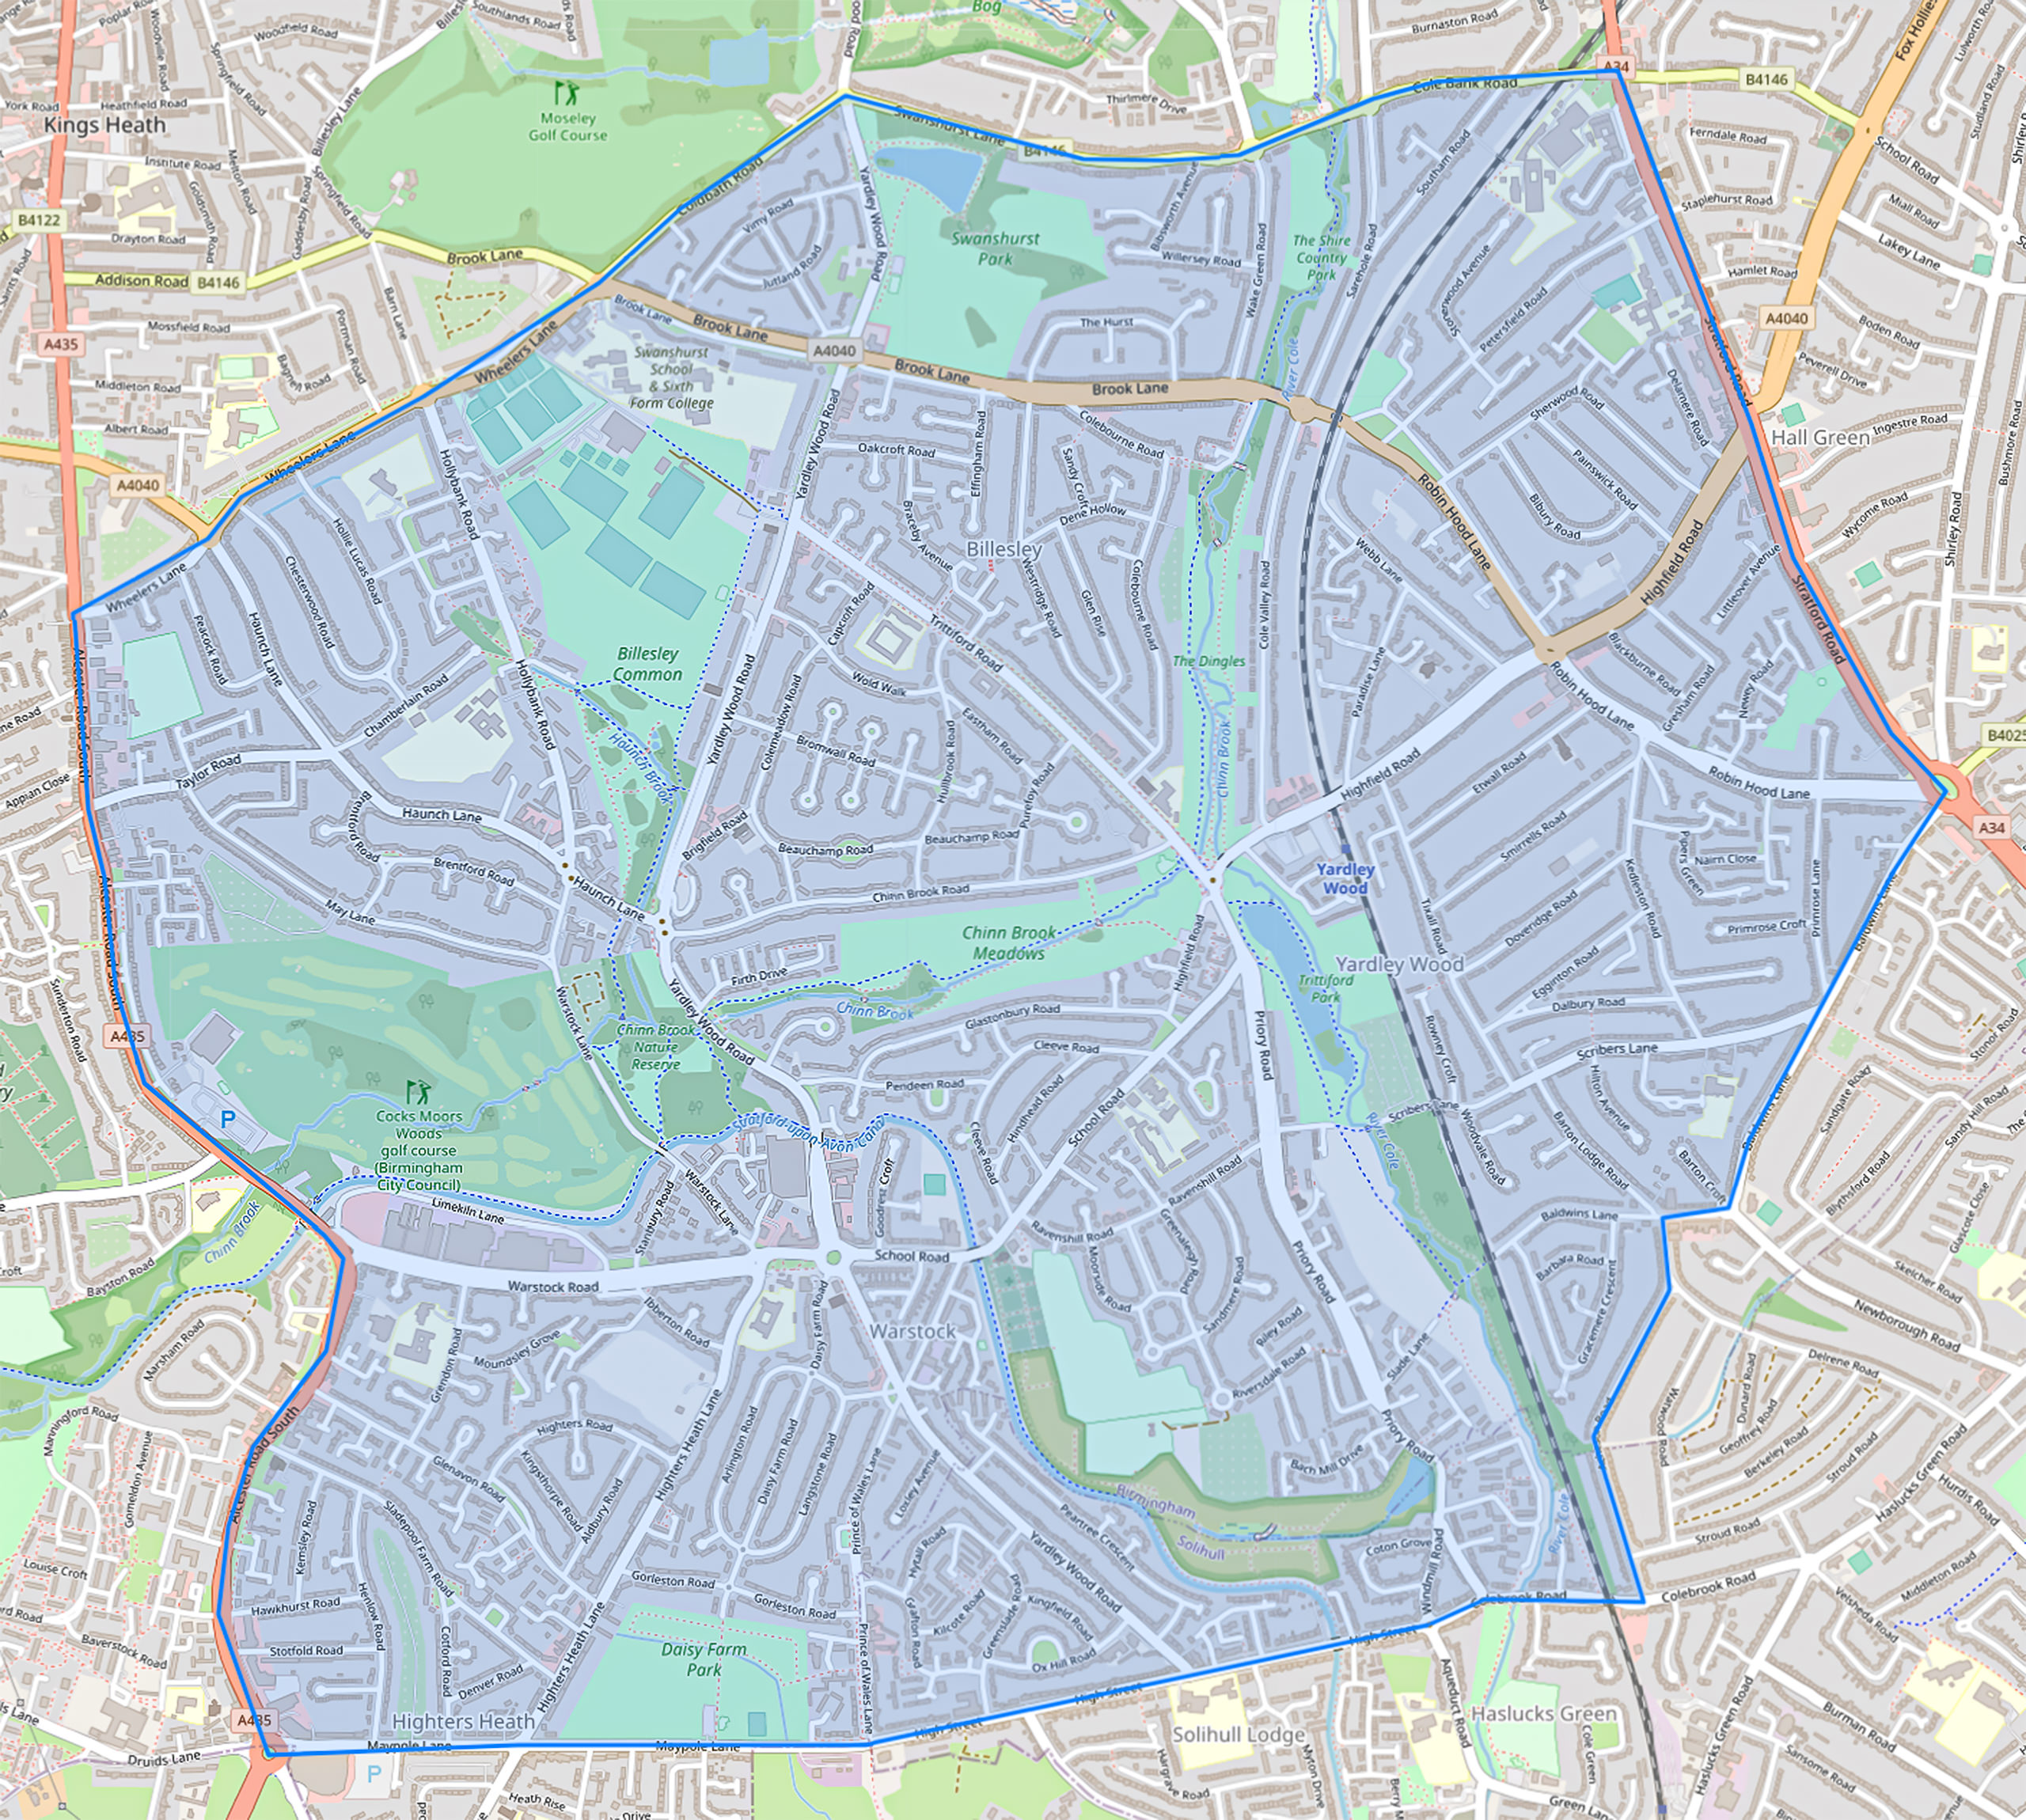

Dear patient

Thank you for notifying the practice of your new residing address; unfortunately you are now outside of our practice catchment area. As a valued patient of the practice we can offer you the option to remain registered with us however we ask that you consider the following:

- We will not be able to offer home visits
- Any difficulties obtaining community services that are based on locality (eg midwifery services or district nurse services etc) are out of the surgeries control

If we do not hear back from you, we will assume you are happy with the above and no further action will be taken.

With Kindest Regards

Yardley Wood Health Centre

